A Project Report
On

“Smart Exam Seating Allocator”

by

RUDRA HITESHBHAI TANK

22SE02CE048

under the mentorship of

Ms. Hemangni Mehta

Assistant Professor, School of Engineering

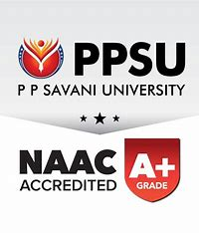

APRIL 2026

P P SAVANI SCHOOL OF ENGINEERING
P P SAVANI UNIVERSITY
NH NO.: 8, VILLAGE: DHAMDOD, TA. MANGROL, NEAR KOSAMBA, SURAT – 394 125. (GUJARAT).

